- Open CSI (Cedars Sinai Imaging) program on desk top. 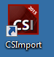

- Open Xeleris program on the Xeleris workstation.
  - Select and push the desired study from Xeleris to Cedars Sinai work station

- In the CSI program select ARG:arg @ localhost, set study date to today. You should see the study that you just sent form Xeleris
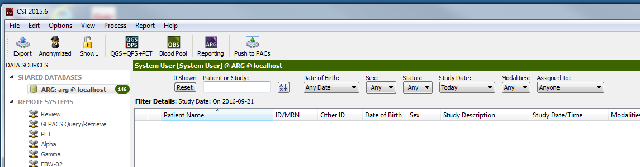

- Select the study of interest and click 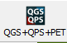

- Select RAW to look at spins to assure good acquisition of the images.
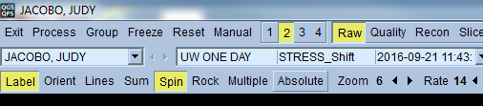

- Next select splash to look at the short axis and horizontal and vertical long axis images.

- 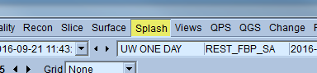

- Next spit and expand the images. Then select step 10 to adjust image intensity (slide black bar, arroe)), assuring that it is similar between REST and STRESS.
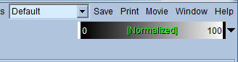

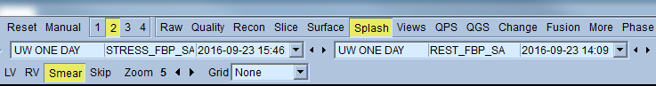

- Be sure to select the static images – STRESS_FBP_SA and REST_FBP_SA

- Once the images are similar in intensity select “cool” to compare rest vs stress images.
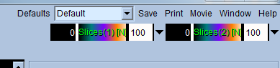
- Compare rest versus stress images in the Short axis (SA), vertical long axis (VLA) and horizontal long axis (HLA) looking for perfusion abnormalities as described previously.

- To look at wall motion you will need to switch to the STRESS and REST gated images, again using the same drop down tab that you selected the static images from

- Next select gate to view the gated images and assess wall motion
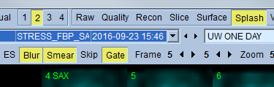

- The Rest and Stress EF, as well as TID measurements will be displayed on the function panel to the right of the screen.

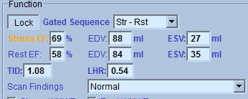

- Be sure to complete the required information on the right side of the screen (Test type, scan findings, etc). Once you are satisfied with your analysis enter your findings under the Extended report tab.

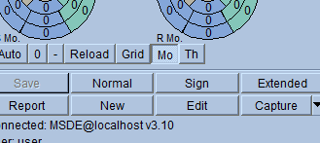

- Select the capture button to save a screen shot with your report.
- Select the Report tab. Copy and past report under the text tab into the RIS system.

